RHEL 8 LVM based Installation
Tasks
1.Boot up a RHEL 8 virtual machine and perform a custom installation using the graphical installer, making sure to select 'LVM' as the partitioning scheme for the root (/) partition.
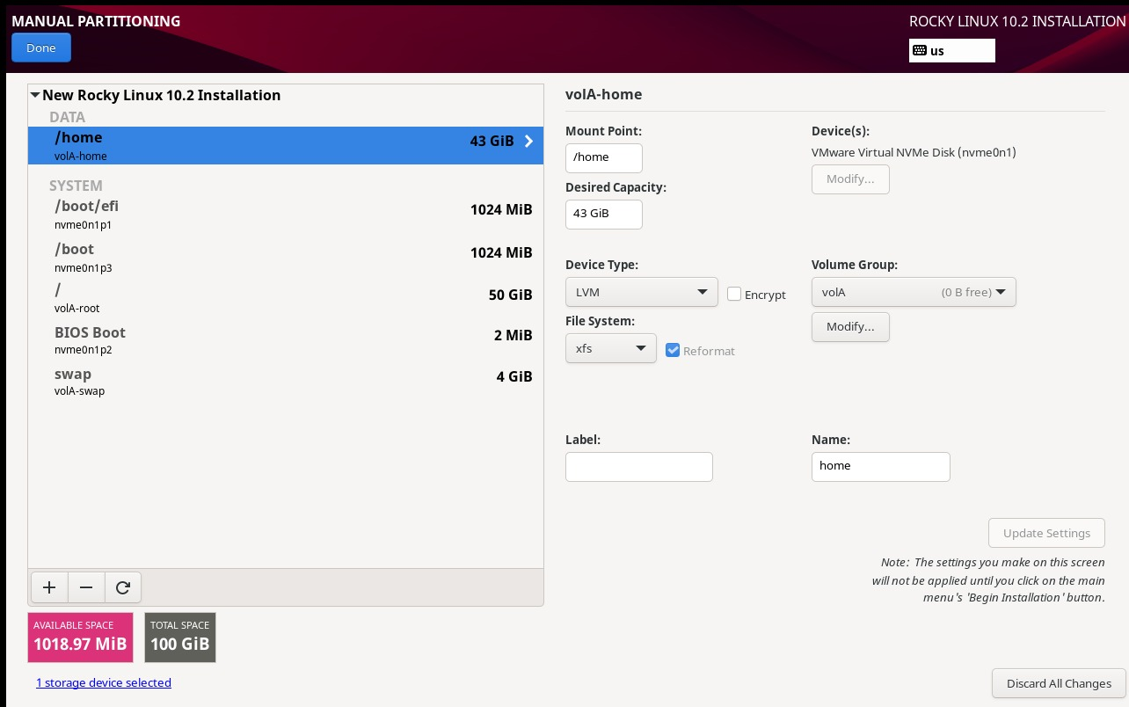

2.Inside your RHEL 8 system, use the 'lsblk' and 'vgs' commands to verify that your root partition is managed by LVM and note down the Volume Group and Logical Volume names.
lsblk
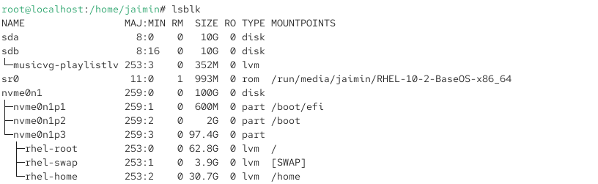
vgs
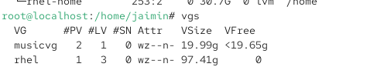
Volume group=musicvg&rhel
Logical Volume=swap,home,root,playlistlv

3.Add a new virtual disk to your RHEL 8 VM, then use 'pvcreate', 'vgextend', and 'lvextend' to increase the size of your existing root Logical Volume by at least 1GB, and resize the filesystem to use the new space.Hint: Use 'df -h' before and after to confirm the size change.
lsblk
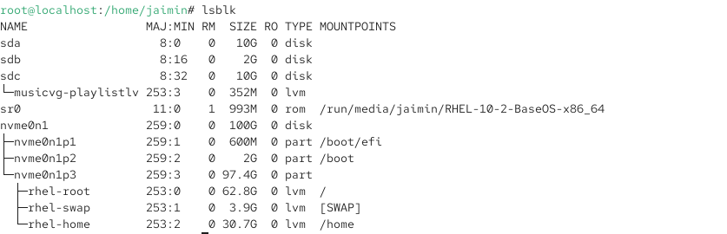
pvcreate /dev/sdb
vgextend /dev/sdb
lvextend -L +1G /dev/rhel/root

lsblk
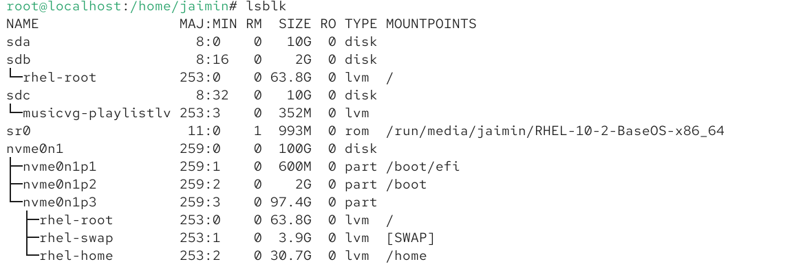
df -h
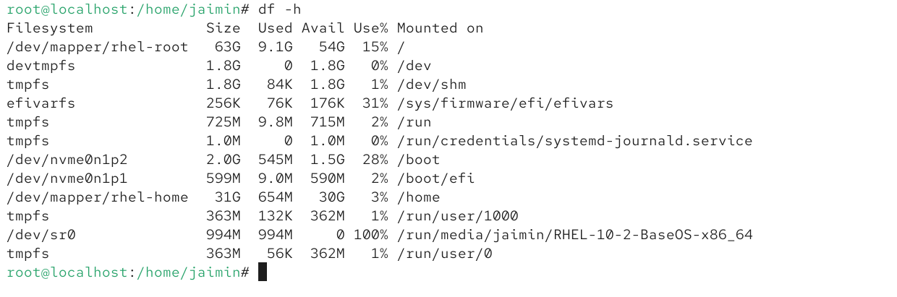

4.Create a new Logical Volume called 'musicdata' of 500MB in your existing Volume Group, format it with ext4, mount it at /mnt/music, and add an entry to /etc/fstab so it mounts automatically on boot.Constraint: Use only command-line tools (no GUI) for this task.
